41.37: a) 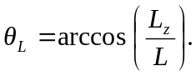 This is smaller for 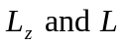 as large as possible. Thus 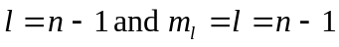
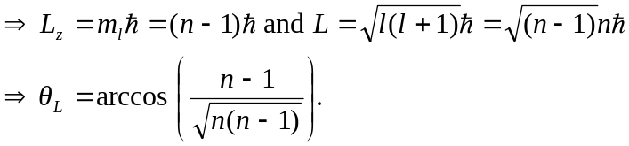
b) The largest angle implies 